WebDAV
The DAV in WebDAV stands for Distributed Authoring and Versioning. WebDAV is an internet protocol like http (which is used to transmit web pages) that can transmit files among other things. If a client application and server application ‘understand’ this protocol, it means that the client application will be able to directly access ‘resources’ (read: documents) on the server, edit them, and save them. Without this protocol the client PC would need to be physically on the same network as the server (like a corporate network). With the protocol the server acts like a remote drive for the client.
The original intention of the protocol was to allow users to edit websites in a more intuitive way. The client html editing application could open an existing web page as if one was working on the server itself (an ‘edit page’ button in Internet Explorer would become active when browsing a page on a WebDAV enabled site). You’d edit the document and save it, and the web page would be updated. The ‘Versioning’ in DAV, if implemented in the server, would allow pages to be rolled-back if the edit was deemed incorrect.
Several years on from the original implementations, WebDAV has become a protocol for powerful document management systems. Among others SharePoint® uses this protocol to allow you to directly access documents, edit them, and save them. Now Document Exchange also supports this protocol thereby bringing the world of WebDAV to DNN.

WebDAV and Document Exchange Paths
As stated above, WebDAV is a protocol designed for online editing of content that DMX implements. Because the two applications are not 100% the same, there are a couple of things to keep in mind here regarding the ‘paths’ to documents:
- DMX uses virtual roots to show content. WebDAV does not know about this. Every document is always accessed through a complete path starting at the ‘portal root’ (see also administrators documentation). This means that your document might look like being ‘Corporate Docs/Sales Docs/MyDoc.doc’, but for WebDAV it could be ‘DMXPrivate/Corporate Docs/Sales Docs/MyDoc.doc’ (in this example DMXPrivate is a folder invisible in the web interface).
- WebDAV needs fixed references to content and cannot handle ‘localized’ paths. So if you’re using the multilingual features of DMX you’ll need to know that the paths WebDAV uses are always in the default language of the portal.
- WebDAV uses the http protocol and therefore paths are ‘encoded’. This means that for instance a space is translated to ‘%20’ for WebDAV. WebDAV addresses can appear a bit messy to end users because of this. Note that the client usually takes care of the translation so you don’t need to worry about this.
- WebDAV paths use a special identifier so that DNN does not try to handle the request, but rather it is left to the WebDAV component of DMX. This identifier is ‘dmxdav.axd’. Your paths are constructed as follows: http://hostname/dmxdav.axd/webdavpath where hostname is the web address of your DNN installation.
- Most WebDAV clients will falsely assume ‘dmxdav.axd’ is the first folder. This is not a serious issue but it might help to be aware of it. The DNN/DMX WebDAV solution works inside DNN and does not use a separate web address for accessing the WebDAV server. Instead it uses the placeholder that the client then interprets as a folder.
To make things easy all items in DMX have “WebDAV link” on the item’s menu:
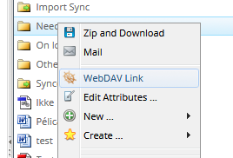
Note this only shows if:
- WebDAV is enabled (Main Options) and
- The logged in user has access to WebDAV (also managed on the Main Options page)

Authentication and Permissions
WebDAV traffic is authenticated like the regular http traffic. You will be challenged to identify yourself when necessary and a cookie is stored at the client. However, the cookie for WebDAV is not the same as the one for the browser. This is a technical issue and has to do with the WebDAV protocol. As a result the following can happen: if you log out of DNN with the web browser, and you’re still logged into WebDAV, the latter will stay alive (note it does not work the other way around).
There is one other thing to note here concerning the difference between DMX and regular network shares. DMX allows you to set permissions on every item. This means you can ‘enlarge’ permissions downward in the document tree (i.e. give more users access) or less. WebDAV clients expect that someone in a subfolder has access to the parent folder as well. Due to the nature of DMX this might not always be the case. As a work around the WebDAV server will grant access to the path (but not the contents) of higher folders, so they will be visible when a user directly navigates to particular folder.

Adding a WebDAV drive to your Windows Explorer
You can also set up DMX content to show up inside the Windows Explorer as a ‘virtual drive’. This means that you can use features like ‘drag and drop’ and ‘New Folder’ to control the content in the DMX. This makes life very easy in online document management. Note that you cannot add the absolute root as the starting place for a virtual drive (we’ve not been able to get this to work for technical reasons). So you’ll need to start somewhere from the first level down. Follow these steps to add a WebDAV drive:
- Copy the path you wish to connect to. Go to the folder in DMX you wish to connect and select “WebDAV link”. A popup will show the link you need:
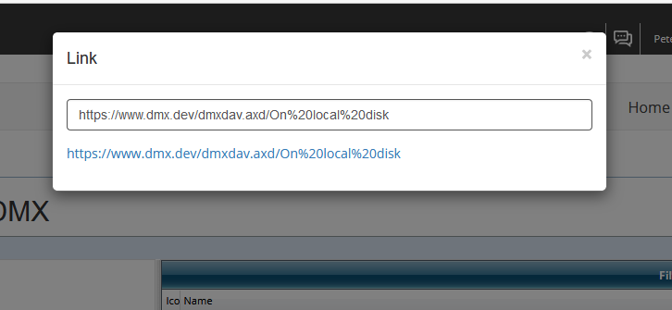
- Go to your Windows Explorer and select “This PC”. At the top you’ll see “Computer” in the menu and when you select it you’ll see a “Map network drive” button:
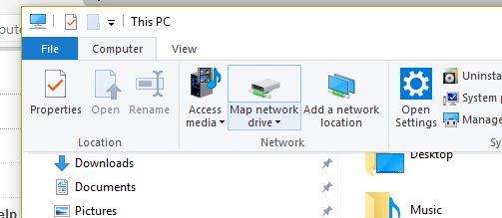
- Click this and use the “Connect to a website that … etc” link at the bottom:
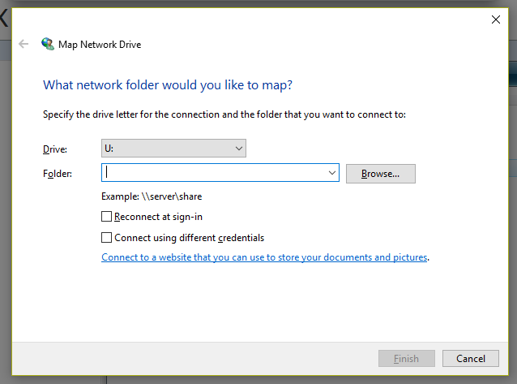
- Select “Choose a custom location”
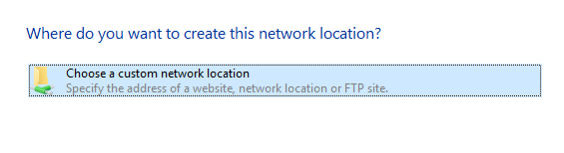
- Enter the link address on the next screen:
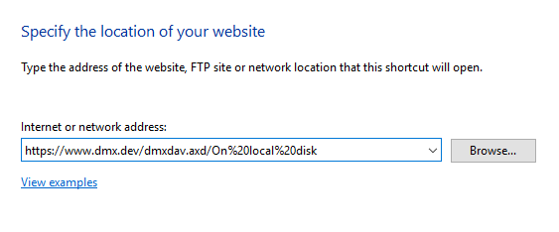
- This should now prompt you to log in. Use your dnn credentials. If all goes well you should see the new folder appear in your Windows Explorer next to other drives.
Note that Windows caches many things to speed up operations. I’ve found that if the network drive didn’t connect because I used the wrong credentials, that I had to log off and back in again to clear Windows’ cache and get it to accept new credentials. The takeaway here is that if things have gone wrong you may need to restart your Windows session to try again.
Once connected you can double click on files and they will open up for you. This allows you to edit files and they will be automatically updated in DMX.

Accessing WebDAV from MS Office
You can use MS office to open up files directly from DMX if you have access to WebDAV. In Word for instance, click ‘File’ > ‘Open’ and enter the path you get when showing the “WebDAV link” for a Word file in DMX. You’ll be prompted for your DNN credentials and you can edit the document directly (click “allow edit” in Word if necessary) and save back to DMX.

Windows Vista
Windows Vista users may experience WebDAV problems and Microsoft have acknowledged that there are issues with the ‘Web Folders’ WebDAV client built into Vista.

